The Richard III Foundation, Inc.
2016 Annual Symposium
Registration Form

The Richard III Foundation, Inc. is pleased to announce its 2016 annual symposium “King Richard III: Politics, Power and People”.

Saturday, October 29

Our conference will be held at the Dixie Grammar School in Market Bosworth. Registration begins at 8:30 am with the conference starting promptly at 9 am and ending at 5:00 pm.

Our speakers and topics are:

- Nathen Amin - Rhys ap Thomas: Friend and Foe

- Anne Crawford - 'Loyalty Binds Me: John Howard and the Battle of Bosworth'

- Matthew Lewis – Richard III in Parliament: In his time were many good acts made

- Mike Ingram – The Battle of Northampton: A Battle Rediscovered

- James Mulraine - 'For by his Face straight shall you know his Heart: Revealing a panel portrait of King Richard III and exploring the popularity of Richard's image in Tudor and Jacobean houses.'

- Dr. James Ross - 'A man of so great nobilytie and knowledge in the warres'? John de Vere, thirteenth earl of Oxford and the Battle of Bosworth

- John Sadler – King Richard III and Henry Percy – Magnates of the North

For a copy of our registration form, or other information on the conference or the Foundation, please contact either Robert Grange at r.g.grange5@gmail.com or Dorothy Davies at dorothy2583@gmail.com or email our corporate office at Richard3Foundation@aol.com.

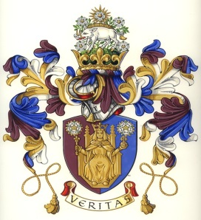
The Richard III Foundation, Inc.
2016 Conference Registration Form

 | Number of Tickets | Prices Per Person
Symposium Package (includes ticket for symposium and membership for one year |  | £45
Symposium (ticket price on the door) |  | £45
Symposium |  | £35
I enclose a cheque for full amount |  | £

Celebrations 2016
Please print your details clearly. Note there are no refunds and tickets are not transferable.
Full Name:

Address:

Postcode: | Telephone:
Email Address:
Guest Full Name:

Address:

Postcode: | Telephone:
Email Address:

How did you learn of conference

To reserve your seat, please mail your registration form along with your check payable to “The Richard III Foundation, Inc.” and submit to Ms. Dorothy Davies, Half Moon House, 32 Church Lane, Ryde. Isle of Wight PO33 2NB. For further questions, please email us at Richard3Foundation@aol.com. Website: www.richard111.com.

